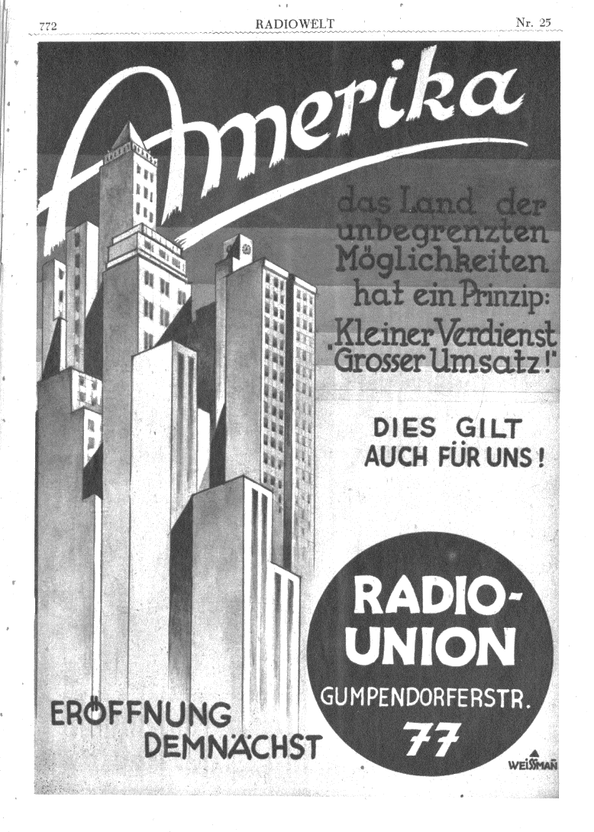

*Dr. Rebecca Unterberger is currently Fulbright Visiting Scholar at the Department of German and Slavic Studies. She has worked as a Senior Scientist at the University of Klagenfurt, Austria, where she also finished her PhD with a doctoral thesis about Ernst Krenek.*

The text-hungry mass press of the inter-war period stimulated the production of travel reports. Authors such as Felix Salten, Marta Karlweis, Ann Tizia Leitich, Jakob Wassermann, Arnold Höllriegel, Arthur Rundt, Egon Erwin Kisch, Maria Leitner, and Roda Roda, the singer Maria Jeritza and the composer Ernst Krenek all took their readers on “inner journeys” to the far-off thus fabled destination *America*.

This lecture discusses selected examples of Austrian travel reports on the U.S. For example, Ann Tizia Leitich who contributed to the bourgeois newspaper *Neue Freie Presse*, was intrigued with the American way of life: she was convinced that the United States should serve as a model for Austria’s future rather than the “bolshevist experiment” of the U.S.S.R. As illustrated by this example, most writing travelers carried Europe, especially Austria in their “mental luggage.” By focusing on their travelogues, traditional preconceptions of the “New World” as well as the First Austrian Republic, its political, social, and cultural habitus, can be examined.

**Rebecca Unterberger**

**Beyond prairies**

**and skyscrapers?**

**Austrian travelogues of the inter-war era on the U.S.**

**Nov.27 2018, 4 p.m., Phelps 6320**